🛠️ PW1 Group 3 Engineering Team Charter

1. Team Name
Project Week 1 Group 3

2. Mission Statement
To create a half adder circuit using transistors and combine with the other team to make a full adder and ensure clear documentations throughout the project week.

3. Goals & Objectives
- Goal 1: Establish a team charter, including key roles, team objectives, and corresponding tasks with deadlines, and norms in the work environment by the end of Day 1.
- Goal 2: Ensure project documentation is complete, confirmed, and accessible to all team members, by Day 4, 11:00 am for the Audit test.
- Goal 3: Conduct initial research on BJT and MOSFET operating principles, and their input and/or output characteristics, complete by Day 2, 12:15 pm.
- Goal 4: Construct functional circuits to test the relevant characteristics of BJTs and MOSFETs, compiling results as plots into a single document by the end of Day 3
- Goal 5: Construct a functional half-adder circuit by the end of Day 4; ensure its compatibility to make a full-adder circuit, verify its operation against the truth table, complete it by the end of Day 4.
- Goal 6: Integrate the circuit compatibility by creating a 4-bit adder using 2 chained full-adders by Day 5, 10:15 am
- Goal 7: Create, record and upload an individual presentation explaining the fundamentals of transistors in three minutes, by 12 pm on Day 5.

4. Team Members & Roles
Name | Role | Responsibilities
Will | CEO (Chief Executive Officer) | Oversees planning and delivery
Luke | COO (Chief Operating Officer) | Ensure overall operational effectiveness and performance
Fawaaz | CTO (Chief Technology Officer) | Delivers and ensure technological realisation of the half-adder circuit
Liam | Quality Assurance Manager | Ensures accuracy and standards are met, prevent defects
Maggie | Electrical Engineer Manager | Manages physical half-adder architecture
Jonny | Project Manager | Ensure correct documentation and deadlines are met

5. Organisation chart
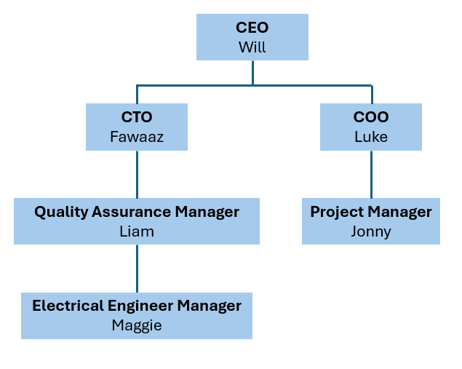

6. Resources & Constraints
- Tools:
  - Project Management: OneDrive, GitHub
  - Electrical System: Oscilloscope, multi-meter, transistor circuit
- Budget: (not suitable)
- Constraints:
OneDrive - limited downtime windows
Oscilloscope – noises will reduce accuracy

7. Operating Norms
- Weekly stand-ups: meet up at the lab at 11:00 AM everyday
- Communication: WhatsApp for regular communication platform outside lab working hours, email for formal reports
- Documentation: All document changes logged in a word document shared on OneDrive, upload outdated version to archive folder,
- Meeting etiquette: Arrive on time, review targets for each day and allocate tasks to everyone

8. Decision-Making Process
- Time-based decisions: Project Manager discretion with CEO taking the final decision
- Technical decisions: Majority vote with CEO taking the final decision
- Emergency fixes: Lead Electrical Engineer discretion
9. Conflict Resolution
- Step 1: Direct discussion between involved team members – find out
- Step 2: Mediation by Project Manager
- Step 3: Escalation to Electronics Manager if unresolved

10. Team Values & Culture
- Integrity: Team members share and work towards the same goal, group decisions are made with consents
- Growth Mindset: We believe everyone can bring consistent improvement; we encourage collaboration between team members to learn from each other and improve together.
- Accountability: Everyone has the responsibility to align with team aims and objectives; encourage and help each other.
- Controversy with civility: The team allow people to share different ideas, we encourage consideration to different ideas and perspectives; we build informed decisions that balances different point of views
- Respectfulness:

10. Sign-Off & Commitment
Name | Signature | Date
Fawaaz Khawar |  | 04/11/2026
Jonny Sizer |  | 02/11/2026
Liam Short |  | 5/11/2026
Luke Sutton |  | 04/11/2026
Maggie Wong |  | 02/11/2026
Will Crook |  | 04/11/2026

